**Software Requirements Specification**

**Application: Recruitment Web & App (Android)**

**Version 1.0**

|  |  |
| --- | --- |
| Synopsis | This document covers the requirement for **AISECT** Web & App (Android). |
| **Author(s)** | Sonal Andotra |
| **Version** | 1.0 |
| **Date** | 17th October 2020 |

|  |  |  |  |  |  |  |  |
| --- | --- | --- | --- | --- | --- | --- | --- |
| **REVISION HISTORY** | | | | | | | |
| **Version No:** | **Date Initiated/Changed** | **Initiated/Suggested By** | **Suggested Source**  **(Review/Suggestion/Approval)** | **Changed Section No/Field No** | **Description (Created/Added/Updated/Deleted)** | **Created/ Changed By** | **Time  Spent (Hours) on  Creation /Rework /Change** |
| 1.0 | October 17th 2020 |  | Internal | Created | Created | Ranjeeta | 5 working days |

Table of Contents

1 Executive Summary 4

2 Stakeholder Categories 4

3 Business Objective 4

4 Scope 4

a. In Scope 4

b. Out of Scope 5

5 Features 5

6 User Characteristics: The use case diagram contains 4 actor Consultancy or Company(Job Provider/Employer), Job Seeker as well as Admin(AISECT Management) , Training Partner Admin Panel 6

7 Functional requirement 7

8 Business Requirement 8

9 Use Cases 9

Use Case 1: Jobseeker/ Job provider/ Employer/ Consultancy/ Training Institute Registration 9

Use Case 2: Jobseeker/ Job provider/ Employer/ Consultancy Login 9

Use Case 3: Jobseeker/ Jobprovider/ Employer/ Consultancy Forgot Password 9

Use Case 4: Admin Manage own Profile 10

Use Case 5: Admin create admin’s profile 10

Use Case 6: Admin manage Recruiters/Employer/Job Provider/Training Institute 10

Use Case 7: Admin / Training Institute Manage Online Assessment Test 11

Use Case 8: Admin manage subscription plan 11

Use Case 9: Payment Processing for Plan 11

Use Case 10: Admin manage job types 12

Use Case 11: Admin manage career-oriented course 12

Use Case 12: AISECT Admin schedule Placement Drives 13

Use Case 13: Training partner schedule placement drives 13

Use Case 13: Training institute manage students 13

Use Case 14: Job provider search job seeker 13

Use Case 15: Job seeker search jobs 14

Use Case 16: Recruiters or Company or Consultancy - Post their job 14

Use Case 17: - Recruiters Or Company or Consultancy - Manage ad’s 15

Use Case 19: - Recruiters Or Company or Consultancy - View Reports 15

10 Business Process Flow Diagram 16

11 Non Functional Requirement 18

12 Constraints 19

13 Assumptions 19

14 Delivery Schedule 20

15 Specification Sign off Sheet 24

# Executive Summary

This document outlines the business, functional and nonfunctional requirements which describes that Om Software needs to develop the functionality mentioned in the below section within the development phase. The project is to develop the web application and android application for the job seekers, job provider, admin as per the functionalities described in scope of work.

# Stakeholder Categories

|  |  |  |  |  |  |
| --- | --- | --- | --- | --- | --- |
| **S.No.** | **Stakeholder Type** | **Stakeholder Category** | **Key Stakeholders Names** | **Area of specialization** | **Responsibilities** |
| 1. |  |  |  |  |  |
| 2. |  |  |  |  |  |

# Business Objective

The objective of the AISECT & placement services is to manage the details job provider/employer/consultancy, search job, post job, job seekers, purchased plans. The purpose of the project is to build the web application where job provider can post the jobs and job seeker can view the job vacancy.

# Scope

The scope of the project is to develop the web application and android application for the job seekers, job provider. The in scope sub-section entitles the functionalities to be implement as per defined the scope of the work and also the enlist the details the functionalities which are not into the scope of the project in the out of scope sub-section.

# In Scope

The scope of the project is as follows:

* The job seeker can view jobs posted by the job seekers and can apply to the job.
* The job provider can post the jobs and can view the details of the job seekers.
* Job seekers or students can enroll directly to AISECT Employment Centre for their services.
* The admin can manage the job seekers and job providers details.
* The plans are provided as per user’s roles for job seekers and job provider.
* The job seekers and job provider can purchase the plans for more usability of the functionalities as per their need.
* The Paytm is used as payment gateway for purchasing the plan.
* SMS API is integrated to web application.
* The registered students can perform assessment test provided by the Eduvantage.
* The AISECT provides the assessment and placement counselling for their registered students.

# Out of Scope

* Multi-lingual Support.
* Video upload resume
* Private Messaging.

# Features

|  |  |  |
| --- | --- | --- |
| **S. No.** | **Feature Name** | **Feature Details** |
| 1. | User Login | The user can login to the application by providing the username and password |
| 2. | User Registration | The can register to the application by providing the required details. The register page will be defined as per the user roles. |
| 3. | Forgot Password | The user can reset the password. |
| 4. | Manage Profile | The user can update the profile details by logging in their account. |
| 5. | Manage Job provider/employer/ consultancy profile | The admin can add, edit, delete the job provider/employer/consultancy profile |
| 6. | Verification of Profile | Verification of newly registered profile is done through the SMS and email. |
| 7. | Upload Resume | Th e job seeker will be able to upload the resume on the application which can be viewed by the job provider. |
| 8. | Download Resume | The job provider can download the resume of the job seeker. |
| 9. | Job Provider Plans | The user can purchase the plan for the following beneficial:   * Customized Job Posting * Candidate Screening * Call Center Services * Banner Ads |
| 10. | Job Seeker Plans | The user can purchase the plan for the following beneficial:   * Customized Professional Resume * Boosting the Resume * Resume Forward * Webinar on career progression * Short term certificate and diploma programs for Career Progression |
| 11. | Manage Jobs | The admin manages the different type of jobs:   * Full time * Part time * Internship * Work from Home |
| 12. | Proceed for Payment | The user can do the payment for the selected plan. |
| 13. | View Jobs | The job seekers can view the jobs posted by the job provider/ employer/ consultancy. |
| 14. | Search Criteria | The job seekers can apply the different filters for searching the specific jobs.  The job provider/employer/consultancy can apply the different filters for searching the particular required candidate as per vacancy. |
| 15. | Send Mail | The job provider/ employer/consultancy can send the email to the shortlisted candidate. |
| 16. | SMS API |  |
| 17. | Assessment test | The students can perform the assessment test |
| 18. | Scheduling Activity for students | The admin can schedule the career counselling session, employment preparation workshop, placements drives for the registered students. |
| 19. | AISECT Services | The training institute can get associated with AISECT. The AISECT provides career-oriented course and placement counselling for registered students. |
| 20. | Training Institute | The training institute gets registered with AISECT, so that training institute can manage their students, provide webinars, offer jobs to their students, online assessment test, placement drives. |

# User Characteristics: The use case diagram contains 4 actor Consultancy or Company(Job Provider/Employer), Job Seeker as well as Admin(AISECT Management) , Training Partner Admin Panel

1. **Admin (AISECT Management):** Admin will be responsible to manage job seeker as well as recruiter or consultancy or company & subscription plan. They can also manage predefined instances notification & view daily/weekly/monthly & yearly report.
2. **Recruitment company or Consultancy/Job Provider/Employer:** Company or consultancy is an actor who informs about the vacancy to candidates & also matches the skills of the referred candidates, required for vacant position & shortlist them. Consultancy or Company is also responsible for interview scheduling.
3. **Job seeker:** Job seeker is an actor who is referred by company or consultancy & applies for the vacancy
4. **Training Partner (Admin Panel):** Training partner are responsible to manage jobseeker and students registered with them for counselling, assessments, searching job, rojgar mela’s and all the offers of the shortlisted candidates of training partners will be shared with training partner and then will be shared by the training partner to the student/jobseeker assigned under their institution.

# Functional requirement

The following is the flowchart of the online portal functional requirement:

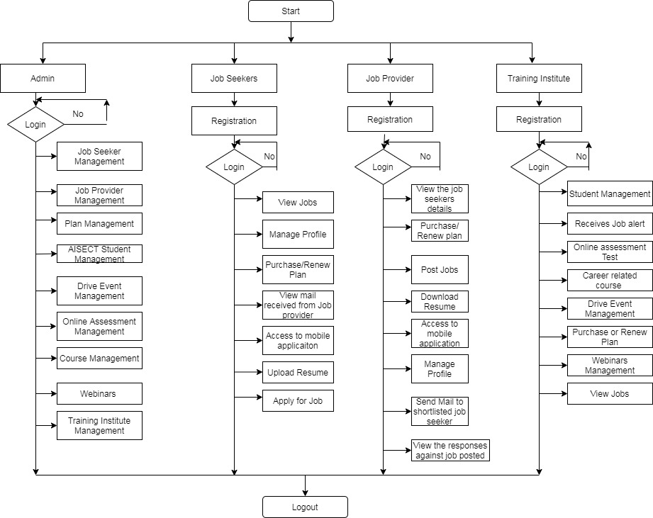

# Business Requirement

|  |  |  |
| --- | --- | --- |
| **S. No.** | **Requirement Description** | **Priority** |
| 1. | The user should be able to successfully register to the platform. | **High** |
| 2. | The user should be able to login to the platform successfully. | High |
| 3. | The user should be able to update their profile details | Medium |
| 4. | The user should be able to update the password | Medium |
| 5. | The user should be able to purchase the subscribed plans for the usage of more customized services as per their role. | High |
| 6. | The admin should be able to manage the users details as per their role on the application. | High |
| 7. | The job seekers should be able to upload the resumes and view the vacancy as per applied search criteria | High |
| 8. | The job provider should be able to download the resumes and view the details of the candidate. | High |
| 9. | The job provider should be able to post the job on the application. | High |
| 10. | The user should be able have access accordingly on the mobile application as well. | High |
| 11. | The user should be verified through SMS API | High |
| 12. | The student shall be able to perform the assessment test provided by the Eduvantage. | Medium |
|  | The admin can schedule the employment preparation workshop for the students and to be informed about the same via email. | Medium |
|  | The admin can schedule the placement drives for the registered students and to be informed about the same via email. | High |
|  | The user can view different types of the plans and should be directed for the payment procedure further after selection of the plan. | High |
|  | The admin shall be able to manage the students, job seekers, job providers | High |
|  | The training partner can get associated with AISECT so that they shall be able to provide job offers, online assessment test, resume builders, career-oriented courses, manage their student profile, placement drives through the AISECT platform. | High |

# Use Cases

## Use Case 1: Jobseeker/ Job provider/ Employer/ Consultancy/ Training Institute Registration

|  |  |  |
| --- | --- | --- |
| **1** | **Description:** | The user can register to the platform by the providing the details on the register form as per selection of the user type. |
| **2** | **Pre-condition** | To stay logged in to system the user shall be able to register to the system. |
| **3** | **Action User Can Perform** | 1. The user visits the website 2. The user clicks the Register link 3. User is taken to registration page where they fill in the required details and clicks the submit. 4. User receives an email for the verification 5. User clicks on the link to confirm their account request. |
| **4** | **System response** | The user get the verification message on registered number and email address. |
| **5** | **Business Rule** | The user should verify over link received via SMS and email address. |
| **6** | **Comm. Trigger** | Email and SMS will be triggered over SMS and email address. |

## Use Case 2: Jobseeker/ Job provider/ Employer/ Consultancy Login

|  |  |  |
| --- | --- | --- |
| **1** | **Description:** | The user can login to the system by providing the email address and password details. |
| **2** | **Pre-condition** | Admin has successfully logged in the Admin area on given Default user id & password. |
| **3** | **Action User Can Perform** | 1. The user go to the website 2. The user click on the login link 3. The user is directed to the login page 4. The user enter the email address and password 5. The user details gets verified from the database. 6. If the details are correct as per database then user get logged in successfully. |
| **4** | **System response** | The user gets logged in successfully. |
| **5** | **Business Rule** | The user should be logged into the account as per their role. |
| **6** | **Comm. Trigger** | The user will be directed to their account. |

## Use Case 3: Jobseeker/ Jobprovider/ Employer/ Consultancy Forgot Password

|  |  |  |
| --- | --- | --- |
| **1** | **Description:** | The user can reset password if user entered invalid password or wants to update the password. |
| **2** | **Pre-condition** | The user gets an error message for entered invalid password |
| **3** | **Action User Can Perform** | 1. User clicks on Forgot password link 2. User enters email ID 3. System verifies an account exists with email ID. 4. User hits reset password button. 5. System confirms password reset instructions were sent to email. |
| **4** | **System response** | The user gets confirmation message over email of password reset along with login link. |
| **5** | **Business Rule** | The user should be registered user in the system |
| **6** | **Comm. Trigger** | The mail is sent to user to continue to login with updated password. |

## Use Case 4: Admin Manage own Profile

|  |  |  |
| --- | --- | --- |
| **1** | **Description:** | The admin can manage their account details in the profile section. |
| **2** | **Pre-condition** | The admin login to account successfully. |
| **3** | **Action User Can Perform** | 1. Admin login to account 2. The admin go to my profile section. 3. The admin clicks on update 4. Admin updates the details 5. Admin clicks on the save button of the profile form. 6. The details of admin gets updated in system |
| **4** | **System response** | The details gets saved successfully in the system. |
| **5** | **Business Rule** | The admin should be registered user and should have valid credentials details to login in to the system. |
| **6** | **Comm. Trigger** | The updated data gets notified on the registered mail. |

## Use Case 5: Admin create admin’s profile

|  |  |  |
| --- | --- | --- |
| **1** | **Description:** | The admin can add their staff as admin for the use of the system. |
| **2** | **Pre-condition** | The admin go to user management section |
| **3** | **Action User Can Perform** | 1. The admin clicks on the create admin 2. Enter the required details 3. Click on the save button 4. System throws successful message. 5. The specific user gets registered as admin in the system |
| **4** | **System response** | The user gets listed as admin in the system and notification is send for the verification over email address and SMS. |
| **5** | **Business Rule** | The user should be added as admin should be through the admin only. |
| **6** | **Comm. Trigger** | The newly registered user can login to system as admin through the accessing the link provided by the system on the mail. |

## Use Case 6: Admin manage Recruiters/Employer/Job Provider/Training Institute

|  |  |  |
| --- | --- | --- |
| **1** | **Description:** | The admin can manage recruiters or employer/ job provider/ training institute |
| **2** | **Pre-condition** | The admin create the new profiles of the user and can manage the registered users |
| **3** | **Action User Can Perform** | 1. The admin can add the user 2. The admin can edit the user details 3. The admin can delete the user |
| **4** | **System response** | 1. The user will get verification updated mail from the system 2. The user will get notified about update profile details through the system over email. 3. The deleted user by the user will get notified about the disability of the system over email. |
| **5** | **Business Rule** | The user should be authorized admin to manage the profile of the users and should have valid admin credentials. |
| **6** | **Comm. Trigger** | The mail will be triggered for each action performed by the admin on the user profile . |

## Use Case 7: Admin / Training Institute Manage Online Assessment Test

|  |  |  |
| --- | --- | --- |
| **1** | **Description:** | The admin or registered training institute can manage career interest through the third party application for job seekers. |
| **2** | **Pre-condition** | The admin or registered training institute provides the test for the job seekers in Online assessment test |
| **3** | **Action User Can Perform** | 1. The jobseeker submit the online assessment test 2. The admin or training institute can view the results of the online assessment test of the job seeker. |
| **4** | **System response** | 1. The result of the job seeker will be recorded in the system. 2. The admin or training institute can view the record of jobseeker. 3. The jobseeker gets mail notification about result of the online assessment test. |
| **5** | **Business Rule** | The jobseeker should be paid user to submit the online assessment test. |
| **6** | **Comm. Trigger** | The record of attempted online assessment test get saved in the system. |

## Use Case 8: Admin manage subscription plan

|  |  |  |
| --- | --- | --- |
| **1** | **Description:** | The admin can manage the subscription plan for jobseeker, job provider |
| **2** | **Pre-condition** | The admin defines the limitation of the usage of the platform services for job provider and job seekers. |
| **3** | **Action User Can Perform** | 1. The admin create plan for specific user role. 2. The admin edit the plan of the specific role 3. The admin delete the plan of the specific user role. 4. The jobseeker and provider purchase the plan. 5. The jobseeker and job provider renew the plan. |
| **4** | **System response** | 1. The updated plan gets saved in the system 2. The deleted plans will not visible to the user on the application. 3. The confirmation mail sent to job provider and job seeker for renewed plans. |
| **5** | **Business Rule** | 1. The user should get registered to purchase plan 2. The admin can edit tor delete the plan which are already purchased by the user and is in active mode. 3. The training institute can also purchase plan as job seeker. 4. The Paytm as payment gateway to be used. |
| **6** | **Comm. Trigger** | The user should get direct to the payment process after confirming the purchase of the plan.  The multiple selected plan should get added into cart of the system before confirming any specific plan to purchase. |

## Use Case 9: Payment Processing for Plan

|  |  |  |
| --- | --- | --- |
| **1** | **Description:** | The registered user(job seeker/ job provider/ training institute/employer/consultancy) can purchase the plan through their login account. |
| **2** | **Pre-condition** | The user view the plan details in the Buy plan section. |
| **3** | **Action User Can Perform** | 1. The user go to Buy plan section 2. The user view the multiple plans 3. The user can select the multiple plan and add it to cart for reference before proceeding to purchase the specific plan. 4. The user select the specific plan from the cart 5. The user confirm for payment proceeding. 6. The user enters valid Paytm credentials. |
| **4** | **System response** | 1. The system directs to Buy plan page 2. The multiple selected plan can be added to cart. 3. The system proceed for payment only for single plan selected by the particular account. 4. The plan can renewed after the completion of the plan. 5. The system will direct to Paytm payment mode after the confirmation of the plan. |
| **5** | **Business Rule** | 1. The paytm gateway should be used to purchase the plan. 2. The single plan can only be purchased at a time. 3. The plan can be renewed. 4. The user should be able to view the plan as per their role. |
| **6** | **Comm. Trigger** | The confirmation message of the payment and plan details will send over the registered email address. The plan will get activated immediately. |

## Use Case 10: Admin manage job types

|  |  |  |
| --- | --- | --- |
| **1** | **Description:** | The admin manage the job types so that user can get search result as per categorized job details. |
| **2** | **Pre-condition** | The admin segregates the job details into specific job types for the better search result. |
| **3** | **Action User Can Perform** | 1. The admin add the job types: full time, part time, walkins, work from home. 2. The admin can edit the job type 3. The admin can delete the job type 4. The job seeker can search the job on basis of the job type. 5. The job provider can post job details as per job type. |
| **4** | **System response** | 1. The added job types get saved into system. 2. The posted jobs is classified to specific job types. 3. The deleted job types will not be displayed to user |
| **5** | **Business Rule** | The user should be able to view the jobs as per the job types. |
| **6** | **Comm. Trigger** | The job gets displayed as per selected job types. |

## Use Case 11: Admin manage career-oriented course

|  |  |  |
| --- | --- | --- |
| **1** | **Description:** | The admin can define job-oriented courses on the platform for the job seeker. |
| **2** | **Pre-condition** | The admin provides the job oriented courses to the job seeker |
| **3** | **Action User Can Perform** | 1. The admin goes to course section 2. The admin adds courses and their details about the courses content provided by the AISECT 3. The job seeker can view those courses details on the portal. |
| **4** | **System response** | The course details get added to the system. |
| **5** | **Business Rule** | The courses details can be defined on the platform which are provided by the business. |
| **6** | **Comm. Trigger** | The courses get notified to jobseekers on the platform. |

## Use Case 12: AISECT Admin schedule Placement Drives

|  |  |  |
| --- | --- | --- |
| **1** | **Description:** | The admin schedules the rojgar melas/placement drives for the registered jobseekers, training institute’s jobseekers |
| **2** | **Pre-condition** | The placement drives are conducted by AISECT only for the students registered with AISECT |
| **3** | **Action User Can Perform** | 1. Admin schedule the placement drives on the application. 2. Admin describes the details of the companies, venue of the drive, experience, job role, location. 3. Admin can view the resumes and application received on the placement drive posted |
| **4** | **System response** | The details of the drives can be viewed by the job seekers. |
| **5** | **Business Rule** | The drives are arranged by the AISECT |
| **6** | **Comm. Trigger** | The mails about the drives are send to jobseekers. |

## Use Case 13: Training partner schedule placement drives

|  |  |  |
| --- | --- | --- |
| **1** | **Description:** | The admin schedules the rojgar melas/placement drives for the registered jobseekers, training institute’s jobseekers |
| **2** | **Pre-condition** | The placement drives are conducted by Training partner for the students/jobseekers registered with them |
| **3** | **Action User Can Perform** | 1. Admin schedule the placement drives on the application. 2. Admin describes the details of the companies, venue of the drive, experience, job role, location. 3. Admin can view the resumes and application received on the placement drive posted |
| **4** | **System response** | The details of the drives can be viewed by the job seekers. |
| **5** | **Business Rule** | The drives are arranged by the Training Partner |
| **6** | **Comm. Trigger** | The mails about the drives are send to jobseekers. |

## Use Case 13: Training institute manage students

|  |  |  |
| --- | --- | --- |
| **1** | **Description:** | The training institute can add their candidate as student in the platform |
| **2** | **Pre-condition** | The training institute are registered and keep track of their students along the services provided to them. |
| **3** | **Action User Can Perform** | 1. The admin registers the training institute. 2. The training institute manage students’ profile in their registered account 3. The training institute use the services provided for job seekers. 4. The training institute schedule placement drives. 5. The training institute conduct online assessment test. |
| **4** | **System response** | The students get added under the specific training institute Id. |
| **5** | **Business Rule** | The training institute to be registered by admin. |
| **6** | **Comm. Trigger** | The training institute is applicable for services provided for job seeker and login to their account with provided credentials by admin. |

## Use Case 14: Job provider search job seeker

|  |  |  |
| --- | --- | --- |
| **1** | **Description:** | The job provider can search relevant job seeker on the platform |
| **2** | **Pre-condition** | The job provider has requirement of the candidates as the per openings in the companies. |
| **3** | **Action User Can Perform** | 1. The job provider post jobs 2. Job providers view the details of job seeker 3. Job provider view the responses received for the posted job 4. Job provider sends the job offer to jobseeker through mail. 5. The job seeker is notified about job openings. 6. The job provider do screening process. |
| **4** | **System response** | 1. Posted jobs are displayed for job seekers in the system. 2. Mail received from the job provider to job seeker 3. The job seeker’s response is send to job provider |
| **5** | **Business Rule** | 1. The job provider and job seeker should be registered user. 2. The job provider can only post number of jobs and can view the jobseekers profile as per applicable service plan. |
| **6** | **Comm. Trigger** | The job provider view the details of the job seekers as per applied criteria. The job provider can download the resumes. |

## Use Case 15: Job seeker search jobs

|  |  |  |
| --- | --- | --- |
| **1** | **Description:** | The job seeker can view the jobs posted by the job provider. |
| **2** | **Pre-condition** | The job seeker searching relevant experienced job |
| **3** | **Action User Can Perform** | 1. Job seeker register to the platform 2. Job seeker manage the profile 3. Job seeker upload resumes 4. The job seeker purchase the plan for advance resume building, resume booster, interview workshop services provided by the platform. |
| **4** | **System response** | 1. The resume uploaded on the system. 2. As per applied search criteria the job are listed 3. The response send to job provider for applied jobs 4. The job seeker gets email notification about job offer. |
| **5** | **Business Rule** | 1. The job seeker should be registered user. 2. The services should be applicable as per purchased plan. |
| **6** | **Comm. Trigger** | The job gets listed as per search and responses are send to job provider. |

## Use Case 16: Recruiters or Company or Consultancy - Post their job

|  |  |  |
| --- | --- | --- |
| **1** | **Description:** | Recruiters or Company or Consultancy can post their job. |
| **2** | **Pre condition** | Job category will be available at portal. |
| **3** | **Action User Can Perform** | 1. Recruiters can post their job (candidate apply on opus site or direct option to download resumes /excel with all details of applied candidates should be provided to recruiter). 2. Add personal details (optional): 3. Name 4. Email id 5. Contact number 6. Email address 7. Company name & website 8. Company Website url 9. Post job with required details: 10. Job Title/designation 11. Work experience: Min & Max 12. Annual salary: Min & Max (Can hide from candidate) 13. No of vacancies (Optional) 14. Location of job 15. Qualification & Software knowledge requirement 16. Post end date 17. Time limit for apply 18. Mention job description 19. Submit all detail 20. Once detail will be verified by admin it will be visible at app & web & job seeker can view the vacancy & apply for them. 21. Can Preview job before making it live or being posted on opus site. |
| **4** | **System response** | Created profile details will save in database & will be available at job seeker profile. |
| **5** | **Business Rule** | 1. Valid email id will saved at database. 2. At a time member can post multiple job’s (as per the subscription plan) & each job having different title/designation. 3. At a time member can’t submit same title/designation job. |
| **6** | **Comm. Trigger** | Email will be trigger at:   1. Jobs details posted successfully. 2. When candidate apply for posted job. 3. When post will be updated successfully. 4. Once posted jobs verified by the admin. |

## Use Case 17: - Recruiters Or Company or Consultancy - Manage ad’s

|  |  |  |
| --- | --- | --- |
| **1** | **Description:** | Recruiters or Company or Consultancy can create their ad’s for walk-ins. |
| **2** | **Pre condition** | Predefined space will be available for ad creation. |
| **3** | **Action User Can Perform** | 1. Recruiters or Company or Consultancy can create ad with required details – 2. Job Title/designation 3. Work experience: Min & Max 4. Annual salary: Min & Max (Can hide from candidate) 5. No of vacancies (Optional) 6. Location of job 7. Qualification & Software knowledge requirement 8. Post end date 9. Mention job description 10. Can add expiry date & as per the added date , ad’s will be expire & disable from the app & web. 11. Submit. 12. They can edit/update existing ad’s details. 13. They can active/.inactivate ad. |
| **4** | **System response** | All ads will be saved at database & it will be expire at the mentioned date. |
| **5** | **Business Rule** | 1. Ad ‘s will be disappear from app & web as per the end date. |
| **6** | **Comm. Trigger** | Email will be trigger at:   1. When ad’s updated. 2. When ad’s activate. |

## Use Case 19: - Recruiters Or Company or Consultancy - View Reports

|  |  |  |
| --- | --- | --- |
| **1** | **Description:** | Recruiters or Company or Consultancy can view reports. |
| **2** | **Pre condition** | NA. |
| **3** | **Action User Can Perform** | 1. Can view all reports at daily/monthly/weekly & yearly. 2. Resume search reports  * No. of searches done by the recruiter with different fields * No. of mass mails done with different fields  1. Job Postings:  * Data for last 6 months or 1 year job posting will be available in the database of Opus   + With the field option of report generation:  1. Date of posting 2. Job Title 3. No. of Responses 4. Job posting status 5. Walk-Ins: Report of Schedule/slots with the details of candidates 6. Download in excel format taking the package which include reports. |
| **4** | **System response** | Reports will be available as per the purchase subscription. |
| **5** | **Business Rule** | 1.Total posted job/apply candidate & buy plan details will be saved at database & it will be available based on search criteria by admin.  2. .All reports can be downloaded in the excel format upon taking the package which includes reports. |
| **6** | **Comm. Trigger** | Email will be trigger at:   1. Once report will be generated on daily /weekly/monthly/weekly basis. |

# Business Process Flow Diagram

**DFD 0 Level for Web Application:**

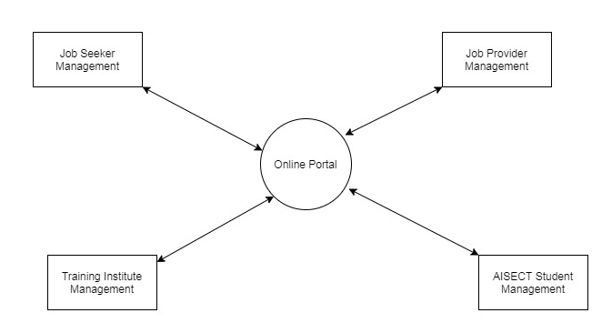

**DFD 1 Level for Mobile Application:**

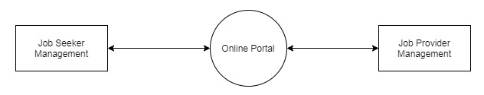

**DFD 1 Level for Web Application:**

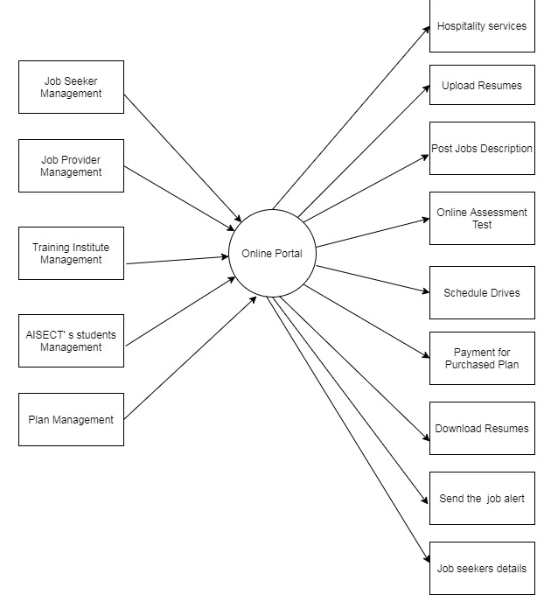

# Non Functional Requirement

**Performance Requirement:**

* The user shall get register within few seconds after clicking on the register button.
* The confirmation or error should be displayed for validating each process and input fields.
* The page should not take time to launch
* The user should be directed to another page on click of option or button or link.
* The files should get uploaded as per defined format.
* The user should be able to login with provided credentials successfully.

**Usability Requirement:**

* The system should be designed in user friendly language English
* The job seeker should be able to search the job as per applied search criteria.
* The job provider should be able to search the candidates as per defined job description.
* Payment procedure of the purchased plan by the user should not be stuck in between and needs to display relevant message on the system.

**Security Requirement:**

* The user should be able their account as per defined roles in the system.
* The password shall never be viewable at the point of entry.
* The newly registered should be verified through mail and SMS.

# Constraints

* The job seeker and job provider are allowed to create the login account and register by themselves.
* Only registered user can apply for the jobs.
* The employers can only post 10 jobs for 3 months in free services.
* The job provider can only view the 5 job seekers job title, designation, experience, name and current location only in free services.
* The size of file to be uploaded upto 4MBs.
* The PDF and doc format resume can be uploaded.
* The Paytm only should be used for the payment processing.

# Assumptions

* The SMS verification is done only for newly registered users.
* The training institute/ partner will get registered through AISECT.
* Logo and Eduvantag link for online assessment to be provided by client.

# Delivery Schedule

|  |  |  |
| --- | --- | --- |
| **Delivery Name** | **Functionalities Delivered** | **Tentative Dates** |
| Home page |  |  |
| Admin Profile | Login  Logout  Forgot password |  |
| Admin Manage admin profile | Add admin  Edit profile  Delete profile |  |
| Admin Manage job provider | Add job provider  Define role  Edit job provider details  Delete job provider details |  |
| Admin Manage job seekers | Add job seekers  Edit job seekers  Delete job seekers  Posted jobs  Resume download |  |
| Admin manage training institute/partner | Admin register training institute/partner  Edit training institute/partner  Delete training training institute partner |  |
| Admin manage online assessment test | View the record of the jobseekers of online assessment test.  Integration of third party application for online assessment test  Access of online assessment test to job seekers |  |
| Admins manage the career-oriented courses | Add courses details  Edit courses details  Delete courses details |  |
| Admins manage the jobs | View jobs  Download the resume  Responses received  Active or inactive jobs  Job types categories fulltime, part time, walkins |  |
| Admin manage subscription plan | Add plan  Edit plan  Update plan |  |
| Integration of the Payment gateway | Payment processing procedure |  |
| Jobseeker Login/Logout | Registration  Login  Logout  Reset Password  My Profile  Update profile  Mail ans SMS verification |  |
| Jobseeker upload resume | Upload the resume  Edit resume  Delete resume |  |
| Job seeker search job | Listing of latest jobs  Search criteria  Apply for job  View the jobs  Send the mail |  |
| Notification for jobseeker | Alert message for job  Mail received from employer  Recommendation of the job |  |
| Job seeker Buy Plan | View list of plans  Payment procedure  Mail notification of purchased plan |  |
| Job seeker online assessment test | Link for online assessment test  Result for the submitted test  Selection of the type of online assessment test |  |
| Job provider profile | Registration  Login  Logout  Forgot Password  Manage Profile  SMS and email verification |  |
| Job provider post jobs | Add personal details  Add Job details  Edit job  Delete job  View responses on the job |  |
| Job provider search job seeker | Search criteria  Download resumes  Send mail |  |
| Training Institute Profile | Login  Logout  Registration  Profile  Forgot Password  SMS and Email Verification  Update profile |  |
| Training Institute manage job seekers | Add job seekers  Edit job seekers  Upload resumes  Delete job seekers |  |
| Training Institute manage online assessment test | View Records of job seekers  Third party link availability |  |
| Training Institute purchase plan | View plan  Select plan  Payment  Confirmation mail for payment  Renew plan  Free services |  |
| Mobile application link on web application home page |  |  |
| Mobile Application for job seeker | Login  Logout  Manage profile  Registration  Upload resume |  |
| Mobile Application for job seeker to search job | Apply for job  Search jobs  Purchase plan |  |
| Mobile Application for job seeker | Online assessment test |  |
| Mobile Application for job provider | Login  Logout  Manage profile  Registration  Forgot Password |  |
| Mobile Application for job provider to post job | Add details  Job details  Post job |  |
| Mobile application for job provider to search job seeker | View job seeker  Download the resume  Send mail  View responses |  |

# Specification Sign off Sheet

|  |  |  |  |  |
| --- | --- | --- | --- | --- |
| **Requirement Specifications Document** | | **Client Name** |  | |
| **Project Name** | **Recruitment Web & App SRS_V1.0** | |
| **Document last modified by:** | | **Ranjeeta Rana** | | |
| **Version Number** | **1.0** | **Date of last revision** | | **16th October 2020** |

**Approval**

**I hereby agree and approve that the specifications in this document constitute the complete scope of this project and will consequently meet the business & functional needs. Any requirement not explicitly mentioned in the specifications will be considered out of scope for this project. After approval, any additions and changes to this document or referred objects will be pursued through the change request process.**

**Approver:**

**Title: _____________________________________________________**

**Company**

**Date: ___/____/_____**

**Signature:** ___________